SET SHUSI

6 Components: Tablecloth to make sushi Chopsticks

Posed Chopsticks Place Mat Unisex

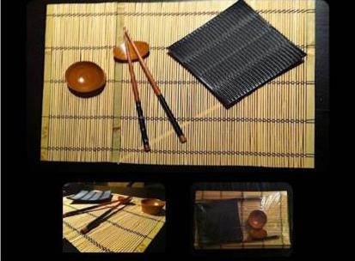

**STOCK**

**Units: 18.000**